From: https://davidstockmanscontracorner.com/the-harlot-of-wall-street-why-the-feds-assault-on-main-street-must-end-part-4/

The Harlot Of Wall Street: Why The Fed's Assault On Main Street Must End, Part 4
By David Stockman. Posted On Monday, November 11th, 2019
A recent Wall Street Journal piece on the raging insanity in the auto loan market tells you why the current record 125 month business expansion is a ticking time-bomb, not a singular success that warrants the Fed doing "whatever it takes" to extend.
Yet extending the current ragged expansion---the so-called mid-cycle adjustment---is exactly what they are attempting to do. Otherwise, how could anyone in their right mind justify cutting rock bottom interest rates by 75 basis points and pumping $215 billion of fiat credit into Wall Street at a time when the U-3 unemployment rate at 3.5% has touched a 50-year low?
Of course, they call this renewed burst of money-pumping "Not QE", but apparently now even the english language means whatever these arrogant fools say it means.
But that doesn't gainsay the truth that money and credit markets are fungible and thoroughly arbitraged, and that in barely 60 days the Fed has removed real government debt from the bond pits at a $1.4 trillion annual rate and paid for it with central bank credits plucked from thin air.
That's right up there in Bernanke's league circa 2008-2009---when at least the bonfires on Wall Street were still glowing bright red.
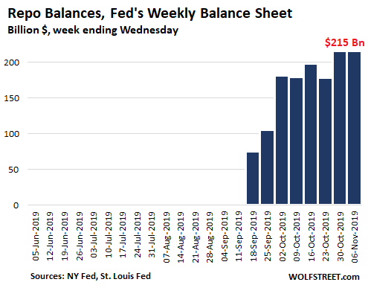
But prolonging the cycle is the very last thing the Fed out [ought] to be attempting. That's because in the era of extreme central bank fostered financialization the longer the cycle endures, the greater the rot that builds up down below.
That is, while the Fed is taking victory laps for surface level "progress" like the irrelevant U-3 unemployment rate of 3.5%, the next round of busted loans, bursting bubbles and mutant malinvestments is being accumulated just below the surface.
In the present case, we are talking about record car loan terms and a record share of auto borrowers who had negative equity on the old loan when they bought a new ride and took out a double-down loan. An especially poignant anecdote in the WSJ story leaves little to the imagination:
John Schricker took out a loan to buy a car in 2017. Then he took out another. And then another.
In two years, the 40-year-old electrician signed up for four auto loans, each time trading in the previous car and rolling the unpaid balance into the next loan. He recently bought a $27,000 Jeep Cherokee with a $45,000 loan from Ally Financial Inc.
Mr. Schricker, who lives in Bethel Park, Pa., said he didn’t intend to cycle through so many vehicles. He replaced one because it had 100,000 miles and another when he went through a divorce, and he changed cars again when his family was expanding.
Mr. Schricker would like to get a new car because the Jeep Cherokee started having mechanical problems this year. He recently discovered the vehicle was in an accident before he bought it, a fact he said the dealership didn’t disclose.
He estimates that even if he sold the vehicle, he would still owe Ally up to $18,000. Ally said it couldn’t comment.
Well, we'd guess it wouldn't. If Mr. Schricker sold the "asset", he'd end up with no car, no way to get to work, no transportation for his family and an uncollectible $18,000 debt.

John Schricker adjusts his daughter's car seat in the back of his Jeep Cherokee. Photo: Kristian Thacker for The Wall Street Journal
Still, it's actually only a matter of time before his clunker gives out or a recessionary downturn causes electrician work to shrink---contingencies what would lead to exactly that baleful outcome.
Nor is this an aberrant case. Fully 33% of customers who traded in cars to buy a new one this year had negative equity, compared with 28% five years ago and 19% a decade ago. These under-water borrowers owed about $5,000 on average after they traded in their cars compared to about $4,000 five years ago.
As the WSJ further notes, one reason for this negative treadmill is that car prices keep rising----so $45,000 loans on rapidly depreciating mid-market cars have become a necessity to keep the wheels turning in much of Flyover America.
Rising car prices have exacerbated an affordability gap that is increasingly getting filled with auto debt. Easy lending standards are perpetuating the cycle, with lenders routinely making car loans with low or no down payments that can last seven years or longer.
The irony here is hard to ignore. The Fed claims to driving interest rates toward the flat-line due to low-flation and the risk of flagging growth---even as main street households are being lured into staggering and eventually fatal levels of debt to keep up with rising prices!
Thus, since January 2007, median weekly earnings of wage and salary workers with a high school education are up 22% compared to a 29% rise in average new vehicle transaction prices. And that gap doesn't even encompass the increasingly frequent and larger amounts of carry-in debt from the last vehicle.
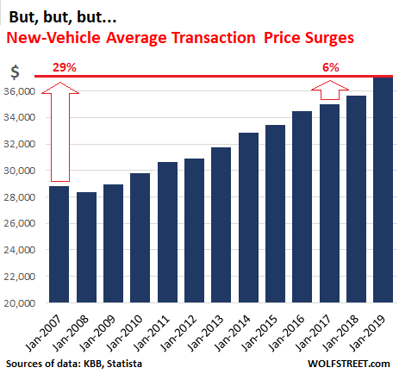
Then again, the "low-flation" brigade in the Eccles Building apparently has no clue about what is actually happening on main street. That's because they see the world through their BLS beer goggles, and the latter says new car prices are only up 5.9% since January 2007 or by just one-fifth of what the lying eyes of industry data trackers actually report.
So what's the sweat?
After all, the BLS' "hedonic adjustments" magically turn a 29% rise in dealer lot prices to just 5.9%. So the above mentioned Mr. Schricker is undoubtedly relieved to know that the $45,000 loan hanging over his head comes with increased quality and functionality on his Jeep Cherokee which apparently got banged up in a plain old car crash.
Stated differently, why in the world is the Fed obsessed with 2.00% inflation when as we showed in Part 3, the most stable measure of the general price level---the 16% trimmed mean CPI---is up by 1.90% per annum since inflation targeting was officially adopted in January 2012?
Or when even more to the point, the BLS's crude indices can't begin to capture the real world complexity illustrated in the simple matter of new car prices. Indeed, in this case the Fed is actually getting the inflation it claims to desire---new car prices are up at a 2.14% annual rate since January 2007.
But in the Eccles Building puzzle palace this is actually called "low-flation" because the BLS' new car price index is up by only 0.48% per annum.
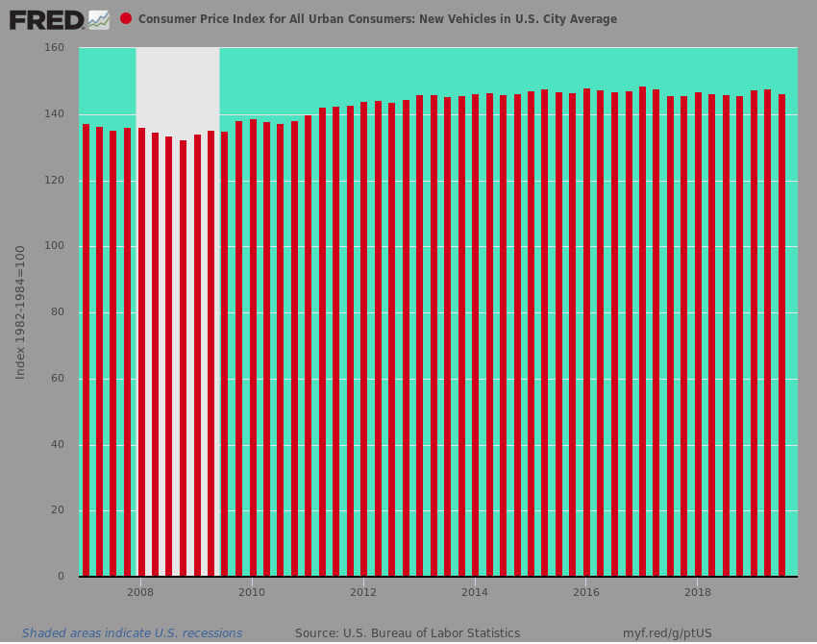
Of course, where this leads is to the dangerous disconnect shown in the chart below: Namely, the main street economy is barely running in place---even as Fed policies cause it to churn deeper and deeper into unsustainable debt.
That's right. New auto sales peaked at 18.5 million units in Q2 of 2005 and notwithstanding all of the Fed's huffing and puffing and egregious money printing in the 14 year since then, they actually posted at 17.7 million units or 4.2% lower in Q2 2019.
Of course, there are now 14.3 million or 13% more households in America than there were in Q2 2005, but to hear the Fed tell it down is the new up when it comes to auto sales. That is 16.3 new vehicle sales per 100 households in 2005 have become, well, 13.8 vehicles per 100 households in 2019.
At the same time, auto debt is just plain up---having rising from $800 million to $1.73 trillion or by 45% during the same period.
So in a nutshell, here is what has happened since the Q2 2005 auto sales peak:
- New auto sales are down 4.2%;
- Vehicle transaction prices are up by 33%;
- Auto debt is up by 45%
Have the Fed heads ever mentioned this non-sustainable main street trend?
That they have not.
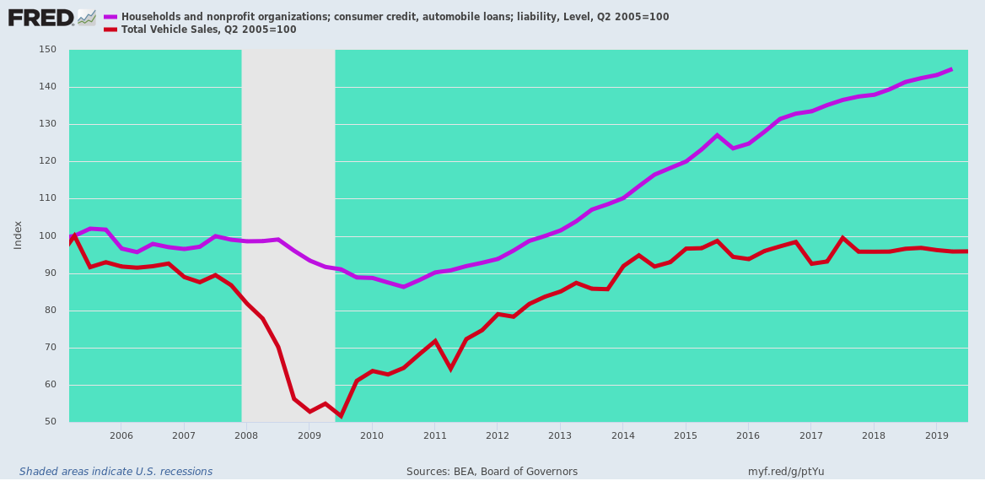
Needless to say, the debt-saturated auto retail sector is simply illustrative of the larger point. To wit, the Fed's ZIRP and QE policies have added precious little to main street activity relative to their natural path of capitalist expansion.
In fact, the peak-to-peak growth rate of real gross value added by the main street nonfarm business sector has steadily diminished---even as the level of so-called monetary stimulus has been sharply escalated.
For instance, the Fed's balance sheet grew at a 7% per annum rate during the tech boom of the 1990s compared to a 15% since the pre-crisis peak in 2007. At the same time, the real growth rate of business value added fell by 50% and now stands far below the 4.1% growth rate that prevailed between 1953 and 1970.
- 1953-1970........4.1%;
- 1990-2000.......3.9%;
- 2000-2007......2.8%;
- 2007-2018.......1.8%
What has grown smartly, of course, is the financial wealth of the top 1% and top 10%. New figures through 2019 leave little to the imagination.
Back when Greenspan launched the modern era of Keynesian central banking in earnest during the October 1987 stock market crash, the top 10% owned 55% of the nation's wealth, while the bottom 90% owned 45%.
Since then, that 10 percentage point gap has widened to 28 percentage points. The top 10% now have 64% of the wealth whereas the share of the bottom 90% has diminished to just 36%; and these figures come from the Federal Reserve itself.
And there is surely no mystery about the cause. The Federal income tax has not gotten more regressive since 1987, which was the low point for the top bracket rate at 28%. It has now gone in the opposite direction---rising to the 40%+ level.
Likewise, the wealthiest households have not gotten any more entrepreneurial or inventive. The rate of new business formations, which is one measure of that, has actually fallen sharply during the last decade or so.
Nope. The source of the widening gap below is relentless central bank induced financial asset inflation during the last three decades.
As more and more sectors of the main street economy have reached a condition of Peak Debt, almost all of the money-pumping effects of Fed policy has remained sequestered in the canyons of Wall Street. That's especially evident in the yawning gap between the very top and the bottom 50% of households.
During Q2 2019, the Fed estimated total household assets at $122.5 trillion. The top 1% of households accounted for $35.5 trillion, representing a $16.3 trillion or 85% gain from Q2 2006.
By contrast, the bottom 50% of households had total assets of just $7.5 trillion in Q2 2019, representing a mere $1.9 trillion gain from the level 13 years ago.

Nevertheless, the Fed's addiction to the printing press has become every [ever] more egregious as one bubble cycle morphs into the next.
Self-evidently, the flare-up in repo rates during September and October was due to the $700 billion of new Treasury borrowing since the end of June---an absurd level of borrowing at the tippy top of an aging business cycle.
As Bloomberg demonstrated this AM, massive cash drain by Uncle Sam caused overnight repo borrowing to soar. That is, there was nothing wrong in the Wall Street plumbing---just a supply/demand equation that was driving money market funding costs higher to clear the market.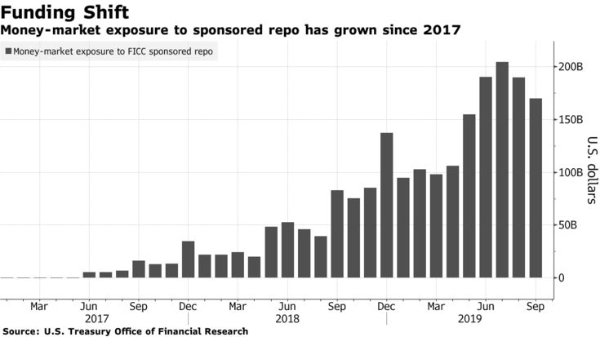
But when you only tool is a hammer, everything literally looks like a nail to the Eccles Building and so they hammered down the repo rate by flooding Wall Street with a new round of liquidity. But the latter had only one place to go---to an even greater inflation of financial assets to the benefit of the 1% and 10%----even as its bloated balance sheet reversed course and once again stands above the $4 trillion mark.
So once gain, the crybabies of Wall Street have gotten their way, meaning that the ultimate bubble crash has become all the more draconian.
